Appendix 1
Letter of Research Recommendation
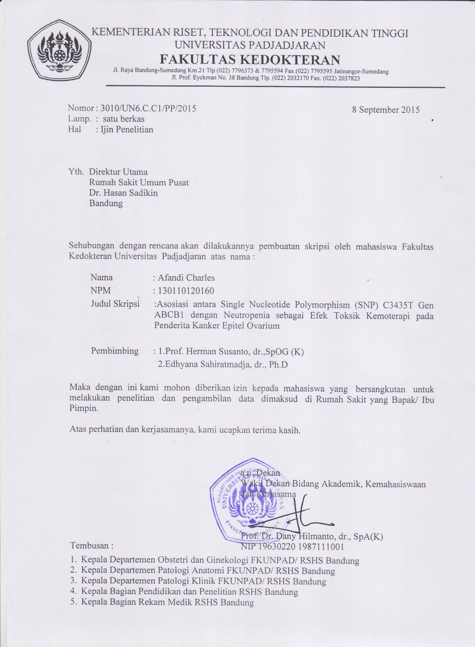

Appendix 2
Letter Confirming Research Approval from Dr. Hasan Sadikin General Hospital
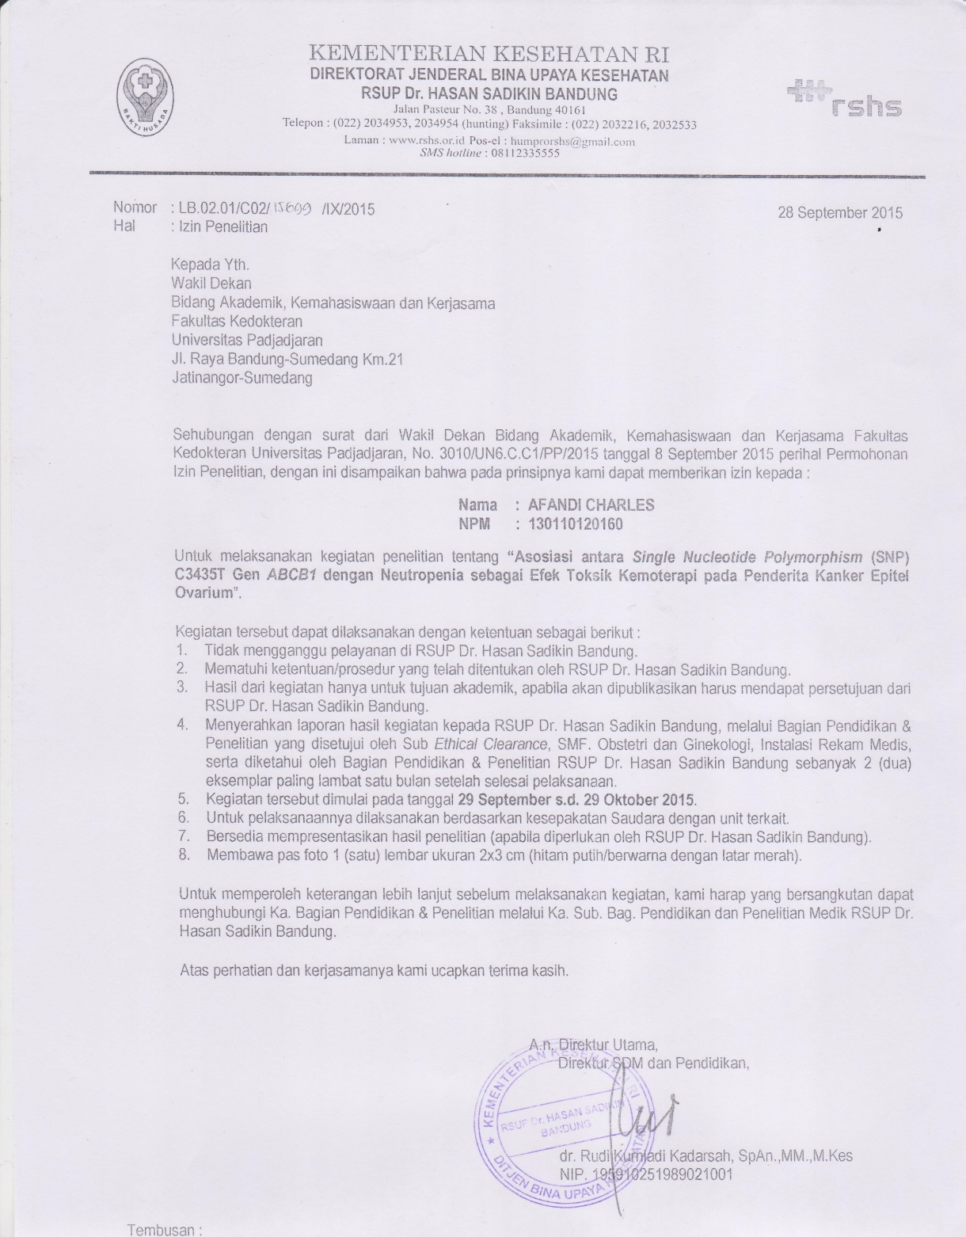

Appendix 3
Ethical Clearance from Research Ethics Committee Faculty of Medicine Universitas Padjadjaran/Dr, Hasan Sadikin General Hospital
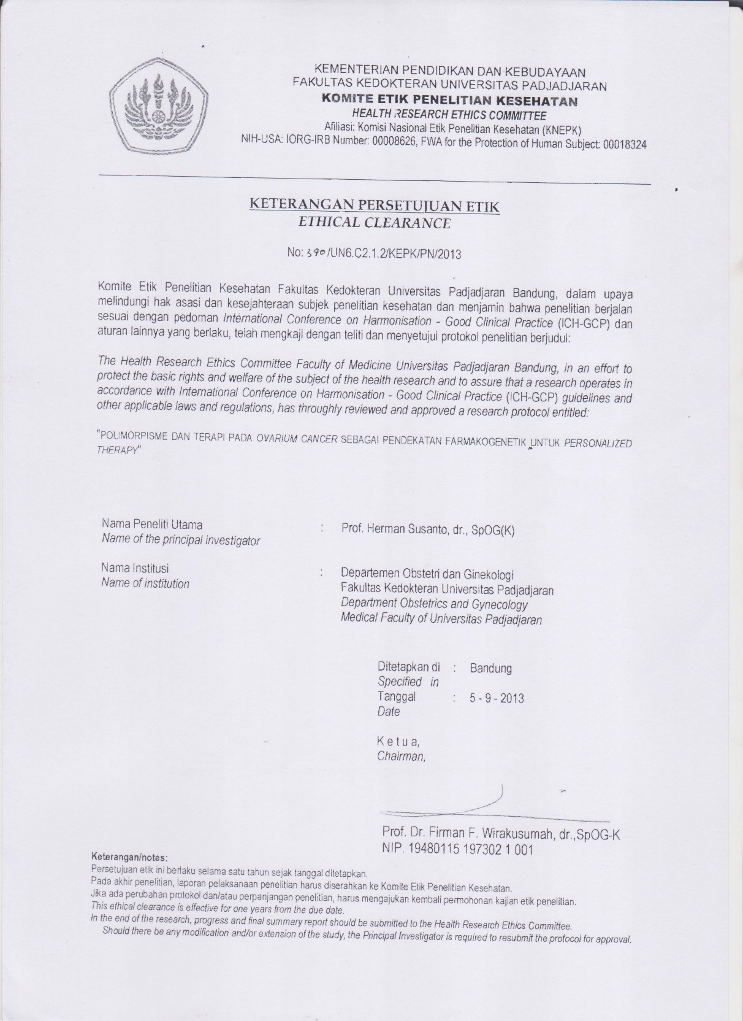

Appendix 4
Raw Data
No. PA | Umur | Paritas (P) | Abortus (A) | Diagnosis | Posisi | Stadium | Kemoterapi terakhir | preHb | pre-Eritrosit | pre-Leukosit | pre-Trombosit | postHb | post-Eritrosit | post-Leukosit | post-Trombosit
141616 | 55 | 1 | 0 | Serous | dextra | III | VI | 9.00 | 3.57 | 6600 | 669000 | 10.9 | 3.42 | 3300 | 207000
141031 | 66 | 6 | 0 | Endometrioid | sinistra | I | IV | 12.40 | 4.91 | 9400 | 330000 | 10.9 | 4.20 | 3500 | 360000
140437 | 45 | 1 | 1 | Undifferentiated |  | III | IV | 11.80 | 4.53 | 8100 | 314000 | 11.6 | 3.94 | 4600 | 215000
140736 | 48 | 2 | 2 | Mucinous |  | III | V | 11.20 | 4.03 | 5000 | 195000 | 6.4 | 2.70 | 2900 | 105000
142310 | 51 | 0 | 0 | Serous | bilateral | II | VI | 13.60 | 5.37 | 8300 | 259000 | 11.3 | 4.36 | 3400 | 194000
142395 | 56 | 3 | 0 | Endometrioid | sinistra | III | VI | 13.10 | 4.13 | 4500 | 381000 | 11.5 | 3.30 | 4700 | 214000
142403 | 29 | 3 | 0 | Mucinous |  | IV | IV | 11.90 | 4.58 | 7000 | 314000 | 5.6 | 1.91 | 3100 | 89000
142495 | 36 | 1 | 0 | Serous | bilateral | III | V | 10.70 | 4.27 | 12800 | 765000 | 11.7 | 3.74 | 3900 | 308000
142557 | 44 | 4 | 0 | Mucinous |  | I | VI | 13.80 | 4.87 | 7700 | 317000 | 9.1 | 2.62 | 7800 | 197000
142688 | 51 | 2 | 0 | Clear Cell | dextra | I | VI | 12.30 | 5.09 | 9300 | 341000 | 11.6 | 4.42 | 6400 | 289000
143514 | 29 | 1 | 0 | Mucinous | dextra | II | III | 12.00 | 4.45 | 9900 | 682000 | 11.1 | 3.73 | 4400 | 277000
144012 | 61 | 2 | 1 | Serous | sinistra | IV | V | 12.40 | 6.42 | 10600 | 440000 | 11.2 | 4.18 | 4100 | 137000
144401 | 40 | 0 | 0 | Serous | bilateral | III | IV | 13.40 | 5.01 | 4900 | 443000 | 10.6 | 3.46 | 3000 | 23000
144722 | 41 | 2 | 0 | Mucinous | dextra | III | V | 12.60 | 4.92 | 12100 | 400000 | 10.7 | 3.70 | 3700 | 229000
145702 | 74 | 3 | 0 | Undifferentiated | bilateral | II | III | 10.60 | 5.16 | 5700 | 333000 | 8.6 | 4.25 | 4800 | 606000
145779 | 51 | 0 | 1 | Serous | dextra | III | VI | 13.80 | 4.83 | 4600 | 246000 | 10.8 | 3.63 | 7300 | 140000
146053 | 53 | 0 | 0 | Serous | dextra | III | IV | 14.60 | 5.20 | 8600 | 345000 | 13.4 | 4.65 | 6700 | 382000
146597 | 22 | 1 | 0 | Mucinous | dextra | III | VI | 11.50 | 4.47 | 8100 | 481000 | 9.9 | 3.17 | 2800 | 87000
147244 | 59 | 2 | 0 | Serous | sinistra | III | III | 12.20 | 4.57 | 6400 | 390000 | 11.2 | 4.06 | 3600 | 119000
147877 | 47 | 1 | 0 | Mucinous |  | III | V | 13.40 | 5.56 | 7300 | 125000 | 11.4 | 4.31 | 5700 | 170000
148326 | 59 | 1 | 2 | Serous | dextra | II | VI | 14.50 | 5.21 | 11200 | 233000 | 13.9 | 4.89 | 7800 | 307000
134389 | 66 | 7 | 0 | Mucinous | bilateral | IV | V | 8.00 | 2.96 | 11900 | 632000 | 12.1 | 4.17 | 4600 | 355000
130x34 | 42 | 1 | 0 | Mucinous | dextra | I | VI | 11.00 | 4.43 | 7800 | 578000 | 10.1 | 3.83 | 5000 | 318000
130176 | 43 | 1 | 0 | Serous |  | III | residif | 13.40 | 6.46 | 6000 | 239000 | 12.0 | 5.19 | 2900 | 175000
133838 | 14 | 0 | 0 | Mucinous | sinistra | III | VI | 12.80 | 4.53 | 4400 | 273000 | 8.3 | 2.86 | 3400 | 143000
135043 | 34 | 1 | 0 | Mixed | bilateral | III | III | 5.50 | 2.05 | 2100 | 210000 | 10.5 | 3.86 | 4300 | 293000
132029 | 48 | 6 | 1 | Serous | dextra | III | VI | 11.70 | 4.15 | 5500 | 530000 | 10.9 | 3.53 | 3200 | 372000
132869 | 23 | 1 | 0 | Mucinous | sinistra | III | III | 5.60 | 3.91 | 14000 | 771000 | 11.4 | 4.53 | 5300 | 482000
130536 | 31 | 1 | 0 | Serous | dextra | II | VI | 8.10 | 3.08 | 8700 | 329000 | 10.3 | 3.58 | 3800 | 249000
133234 | 61 |  |  | Endometrioid | bilateral | residif | IV | 12.80 | 4.16 | 7200 | 199000 | 11.4 | 3.76 | 4000 | 102000
138899 | 60 | 2 | 0 | Undifferentiated | bilateral | residif | IV | 10.70 | 3.46 | 7000 | 400000 | 8.9 | 2.84 | 3000 | 181000
133875 | 51 | 2 | 0 | Mucinous | sinistra |  | III | 8.90 | 3.92 | 18900 | 483000 | 8.8 | 3.59 | 4500 | 98000
135196 | 36 | 3 | 0 | Endometrioid | bilateral | III | V | 10.60 | 3.81 | 7200 | 343000 | 10.4 | 3.24 | 4000 | 315000

